[brainrot connotations (Responses)](https://docs.google.com/spreadsheets/d/1cwUNO-P8hNk1zykJi9a2jmTOS6GedYOpB57psjCc6Cg/edit?resourcekey=&gid=1920248934#gid=1920248934)

**Demographic and Basic Info:**

To gain deeper insights into public perceptions of brainrot speech, we surveyed the college community in the Greater Boston area and obtained the following results. These findings will be compared with ratings by LLMs and analyzed to illustrate how demographic factors, particularly gender identity, influence people's connotations of certain words.

Before rating each word, we asked each participant to fill out a short question of their gender identification.

In the survey, we have left an open response to this question by acknowledging that the categorization of gender below can be problematic. In accordance with the principles of Data Feminism: we encourage you to "challenge the gender binary, along with other systems of counting and classification that perpetuate oppression." (Catherine D'Ignazio and Lauren F. Klein)

**Total Response:** 126**; Range:** 3 days

**Demographics:** >95% college undergraduates, >5% graduate students

**Gender Identification:**

5 refuses to respond, 61 male, 50 female, 10 non-binary

**Acknowledgement Request:**

38 Overall, 25 male, 11 female, 2 non-binary

We would love to acknowledge our participants for their valuable contributions to this project. In the survey, we have an option for participants to put their names to be acknowledged. We have received 38 responses overall, with 25 male participants, 11 female participants, and 2 non-binary participants.

| Alexx McCarthy, Amia, Angad Chhibber, Austin, Austin Spears, Bailey,Ben Dover,Big Boy Rick, Big Nev, Brian G, Chloe xie, Danny, Emma Culley, gloria manhey, Grace Hennessy, Hayden Dunn, Henry Tejada Deras, “I am the skibidi gyatt”, Johndale DaQuavius, “Just happy to help :)”, Kenneth, Manas, Michelle Yun, Nai , Nate Prickitt  Neville Clancy, “No”, Olivia, Saltanat Alisheva, Sam W, Shixun Song, Tamás Regan, The Skibidigyattler, Ella Mackinson, “Why not: Patrick Wray”, andrew cai, Zach Zheng  Zaraius |
| --- |

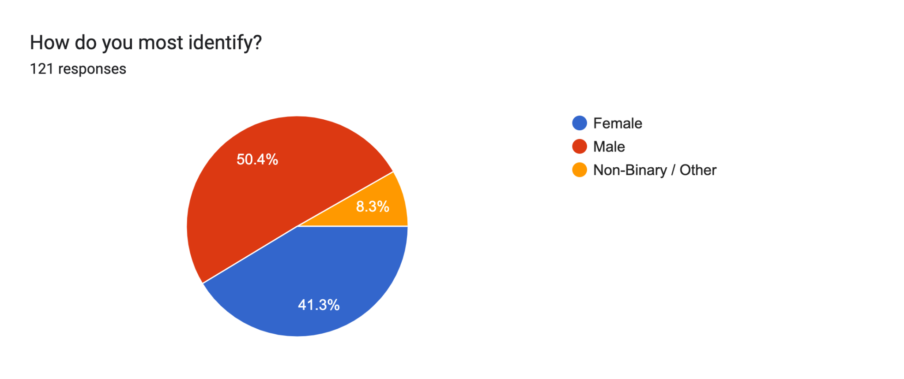

In this graph, there are no significant discrepancies between the ratings from different groups of participants based on gender identity. However, certain words such as “sigma,” “alpha,” and “rizzler,” which have roots in pickup culture, are rated slightly lower by female participants and even lower by the non-binary population, though not by a large margin. Surprisingly, these words are still generally perceived positively, which may be attributed to the high number of male participants in this research.

This graph focuses on the list we created for words rooted specifically in non-masculine culture. Interestingly, there is a significant discrepancy between the ratings from male participants and those from female and non-binary participants, with male ratings being notably lower. However, the words on this list generally receive significantly higher ratings compared to the general list, largely because these words typically serve as compliments originating from LGBTQ+ culture rather than from gaming or pickup culture.